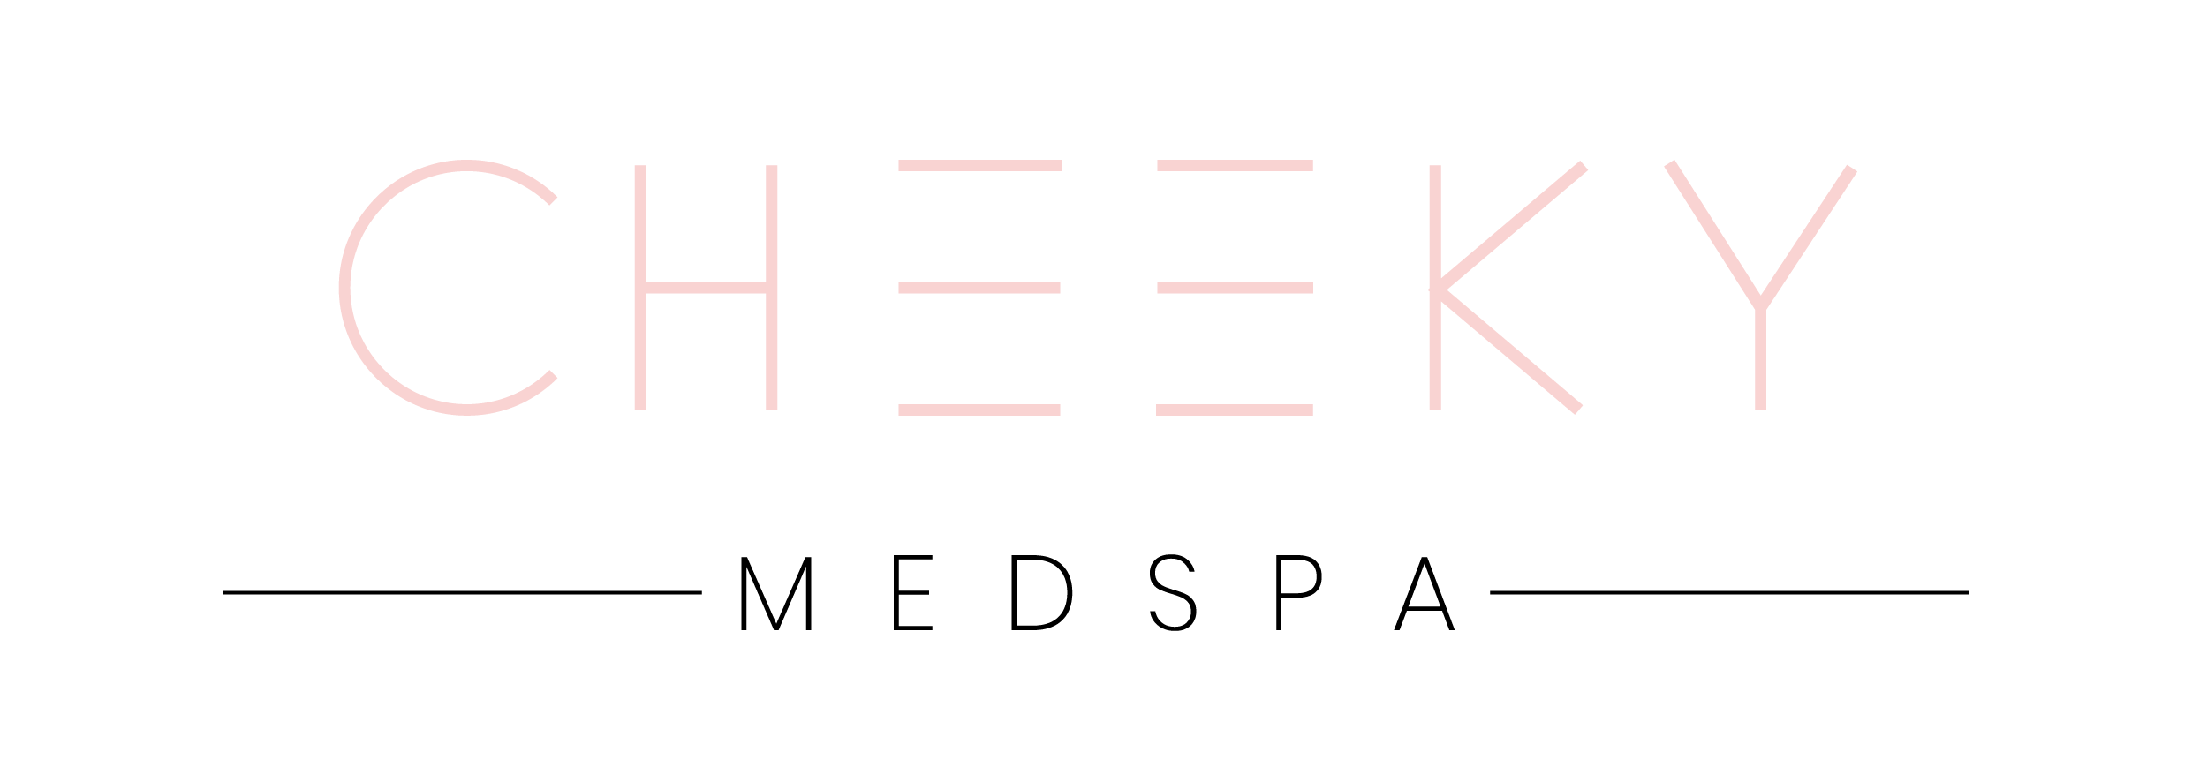
Name:__________________________________________________________________________________________________
LASH AND BROW TINT CONSENT FORM

Have you ever used hair color before? Yes/No
Have you ever had an allergic reaction to hair color? Yes/No
Do you wear contacts? Yes/No

List any allergies you have:

________________________________________________________________________________________________________

Have you ever had your brows or lashes tinted? Yes/No

If you had an adverse reaction to a previous tinting, please explain:
_______________________________________________________________________________________________________

Although every precaution will be made to ensure your safety and well-being before, during and after your tinting application, please be aware of the possible risks below. Please initial:

_____I understand that tinting lashes or brows has some inherent risk of irritation to the orbital eye area, including
the eye itself, and could result in stinging or burning, blurry vision and potentially blindness should the tint enter into the eye.
_____I understand that if the tinting agent, developer, or mixture of both accidentally comes into contact with my eye, my eye will be flushed with water and medical attention may be required.
_____I understand that some irritation, itching or burning may occur to the skin which comes in contact with the tinting agent.
_____I understand that there may be some residual dark staining left on the skin following the tinting process of either my lashes, brows or both. This will fade and go away within a short time.
_____I understand that, while every attempt will be made to provide me with my chosen color, everyone’s hair absorbs color differently and my final results may not be the color I initially wanted.
_____I understand that over the course of several weeks, the tint will gradually lighten and fade. Re-tinting will be required to keep the new color fresh. Most clients need to re-tint every 3-4 weeks.
I have read the above information. If I have any concerns, I will address these with my skin care therapist. I give permission to my therapist to perform the tinting procedure we have discussed, and will hold him/her and his/her staff harmless from any liability that may result from this treatment. I have accurately answered the questions above, including all known allergies, prescription drugs, or products I am currently ingesting or using topically. I understand my esthetician will take every precaution to minimize or eliminate negative reactions as much as possible. In the event I may have additional questions or concerns regarding my treatment, I will consult the esthetician immediately. I agree that this constitutes full disclosure, and that it supersedes any previous verbal or written disclosures. I certify that I have read, and fully understand, the above paragraphs and that I have had sufficient opportunity for discussion to have any questions answered. I understand the procedure and accept the risks. I do not hold the esthetician, whose signature appears below, responsible for any of my conditions that were present, but not disclosed at the time of this skin care procedure, which may be affected by the treatment performed today.

Client Name (Printed) _____________________________________________ Date: ______________________

Client Name (Signature) ___________________________________________ Date: ______________________

Esthetician ______________________________________________________ Date: ______________________

